HelpDesk Process Manual

1) Login with Calculus ID & Password.
Select “Helpdesk Support -> Generate Incident Ticket”

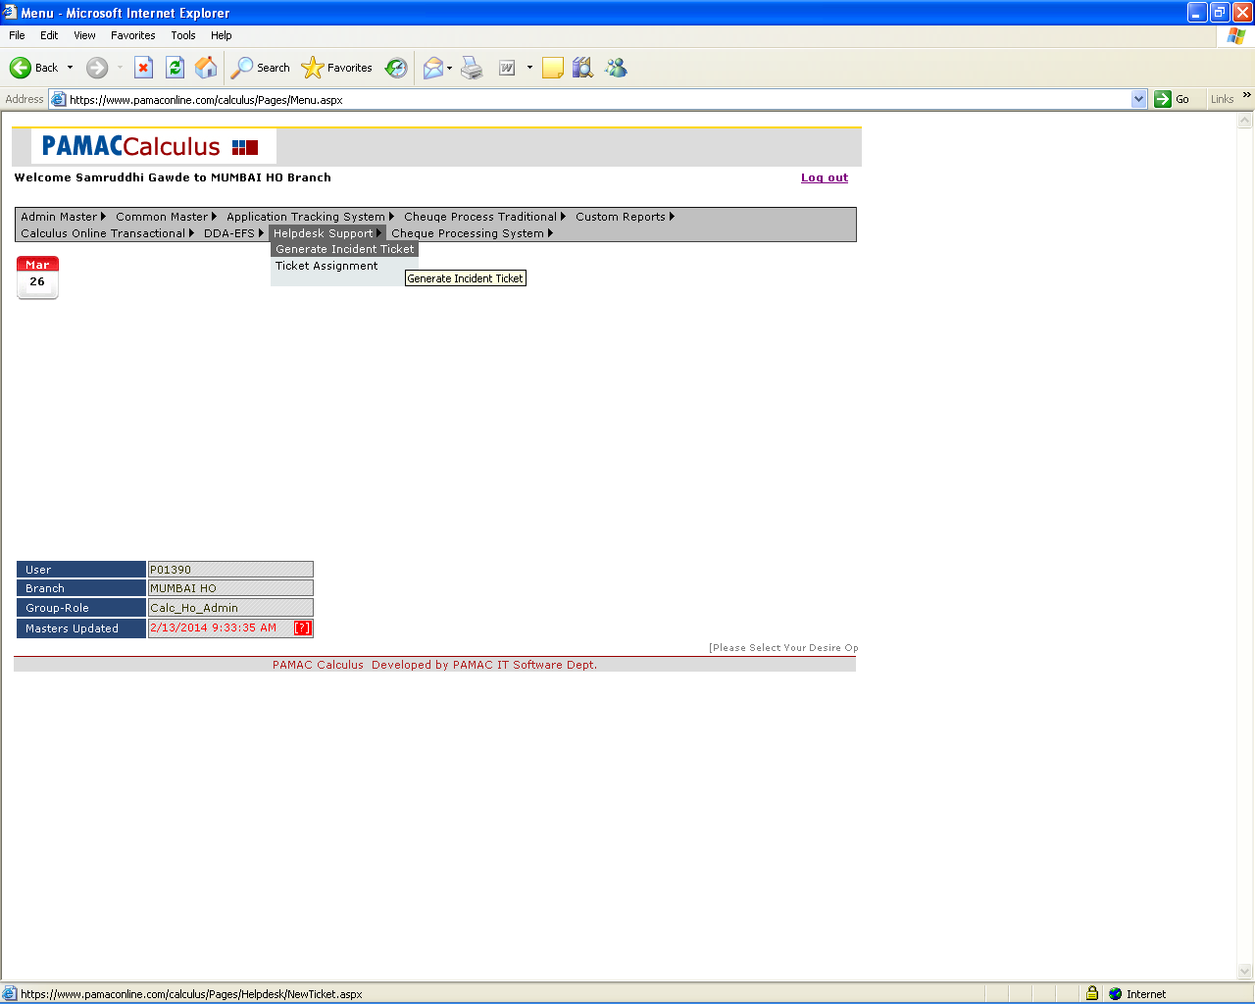
2) Generate Ticket by filling all the details.
User need to select his/her department from Department option, Problem Type & Details of the Problem from Problem Type and Problem Detail options respectively.
User can write his Comments/Remark and he/she can attach particular file from Attachment option.

After generating the ticket, user will get his/her Ticket No. and the records will get displayed in the Grid view in descending order of ticket generated Date.
User can view ticket Assigned To, Priority, Supervisor Remark and Ticket Status of current & previous tickets generated.

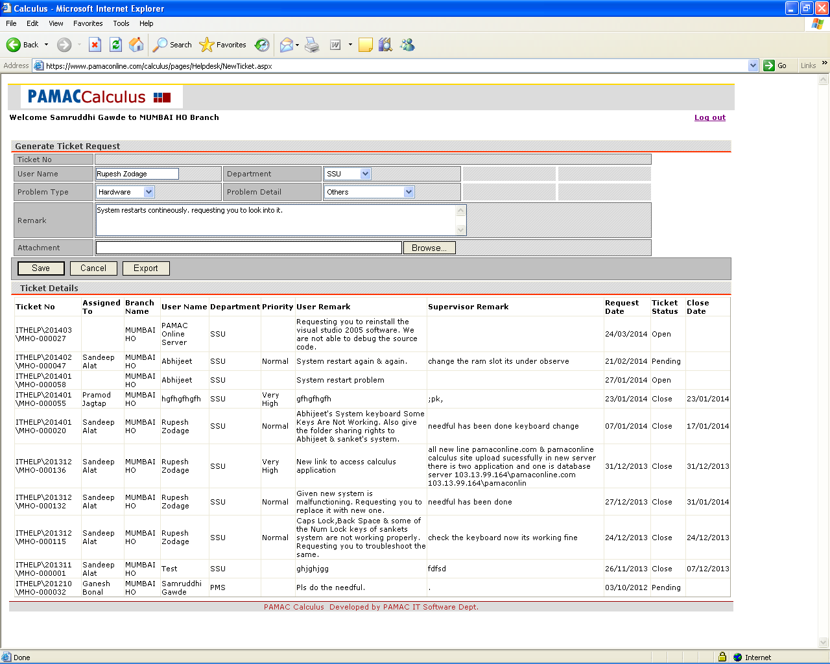

User can see his/her ticket status in table.
User also can generate the Excel report for the same.
3) To assign the tickets generated by user.
Select “Helpdesk Support -> Ticket Assignment”

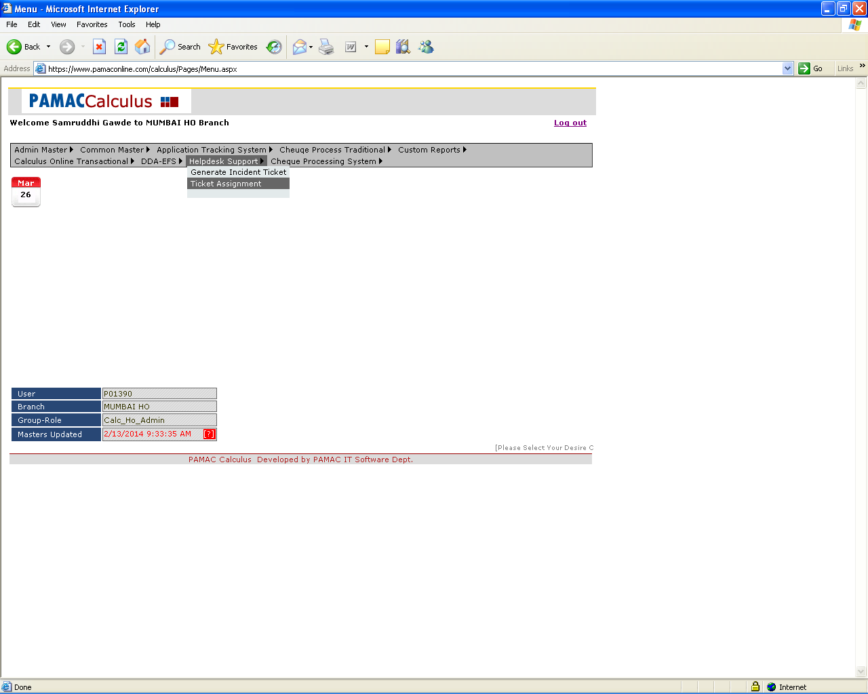
4) This window will get open to the Authorized User(s) only who has the rights of assigning tickets to Ticket Handlers.
Authorized User(s) can search the ticket requests from options shown in below screen.

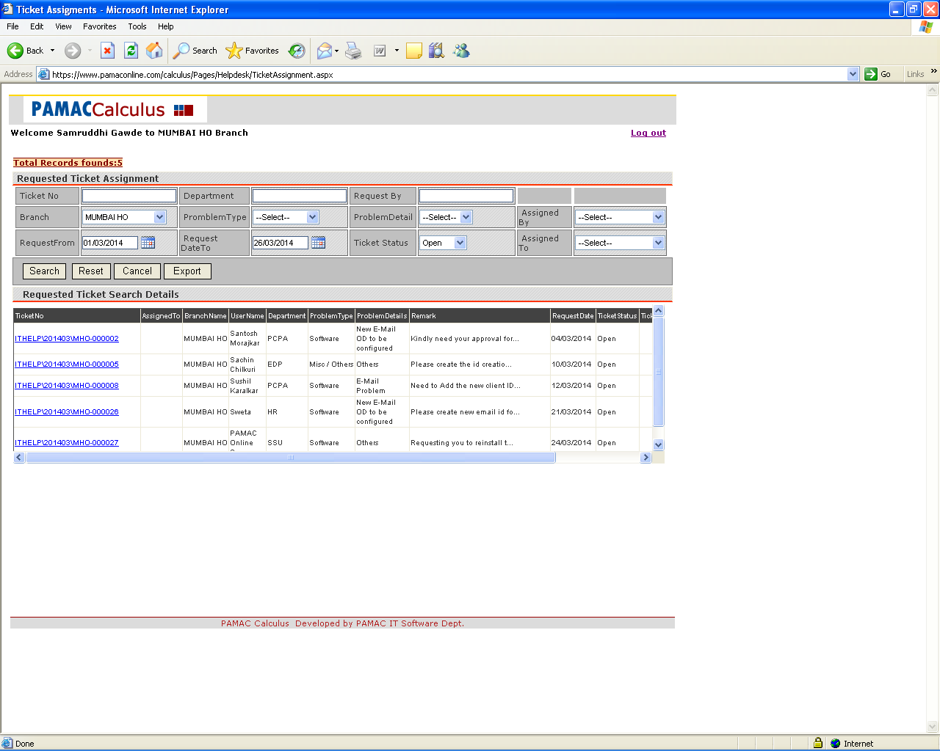
5) Authorized User(s) can Export the ticket request data by clicking the “Export” button and can Open/Save/Cancel the Export report.

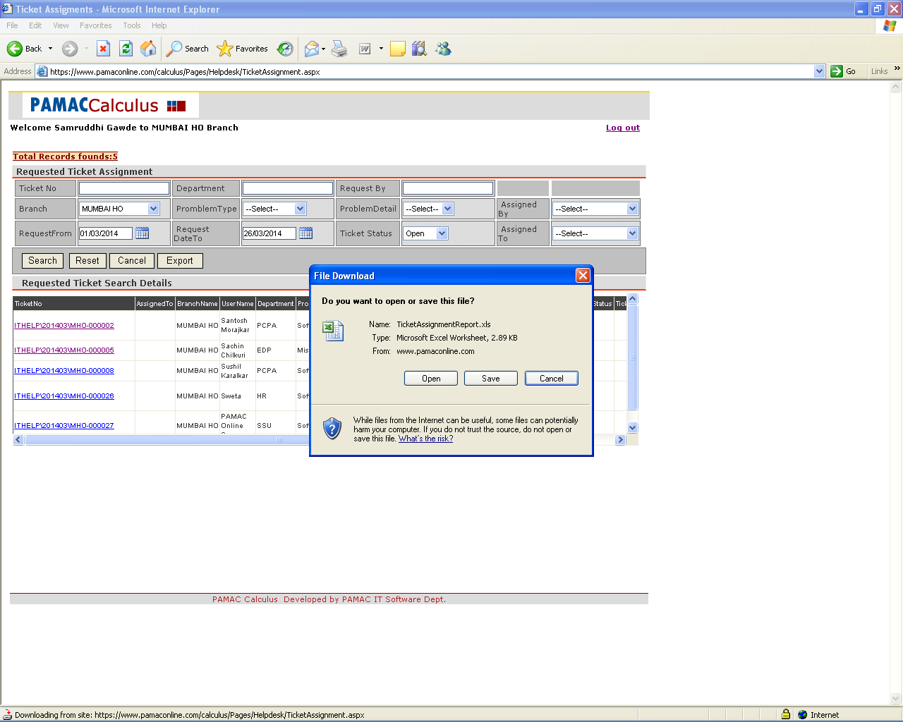
6) By clicking the “Ticket No.” from Grid view shown in Point #4, Authorized User(s) will get the below screen and he/she can assign the tickets to particular Ticket Handlers from “Assigned To” option.
Authorized User can set “Ticket Status”, “Type”, “Priority” and “Update Remark” as per the Ticket request.

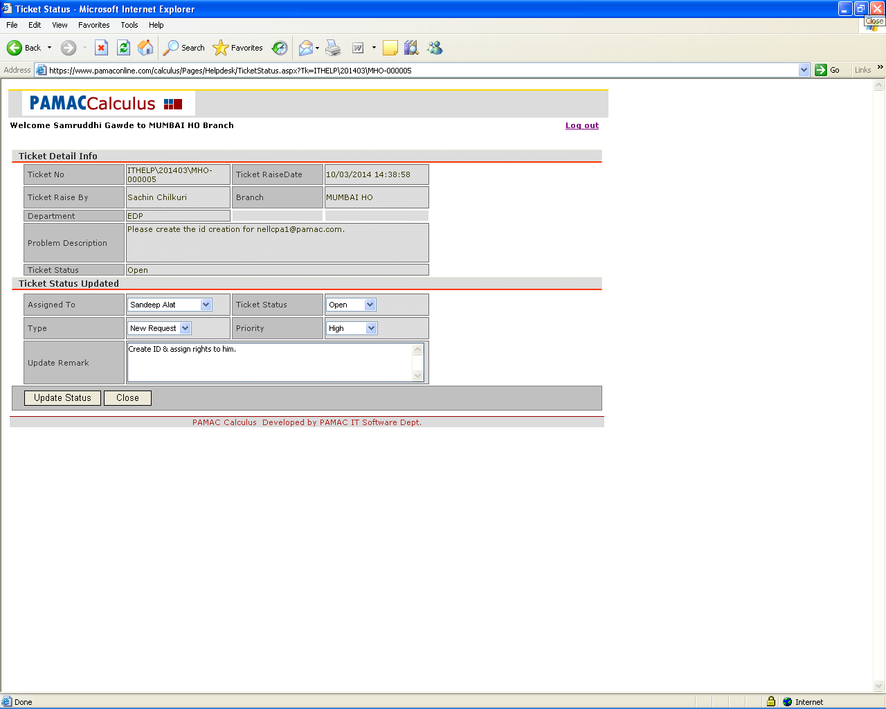
7) If the Ticket Status is “Pending” then it will reflect in “Requested Ticket Assignment” tray & it need to assign again to particular Ticket Handler & Close the same as per
Point # 4 and 5.

For Example:

